Project Design Phase-II
Data Flow Diagram & User Stories

Date | 27 January 2026
Team ID | LTVIP2026TMIDS36395
Project Name | Automated Car Catalog System For Enhanced  Showroom Management
Maximum Marks | 4 Marks

Data Flow Diagrams:
A Data Flow Diagram (DFD) is a traditional visual representation of the information flows within a system. A neat and clear DFD can depict the right amount of the system requirement graphically

Processes:
- Catalog Management – Admin creates catalogs and categories.
- Item Management – Admin adds car models with pricing, images, and descriptions.
- User & Role Management – Admin assigns roles and groups.
- Request Workflow – Users place orders via Service Portal; approval process initiated.
- Notifications – System sends approval/rejection emails.

External Entities:
  - Admin
  - User

Data Stores:
  - Catalog Table
  - Category Table
  - Car Items Table

  - Users Table
  - Roles/Groups Table
  - Cars Fulfillment Task Table
Example: DFD Level 0
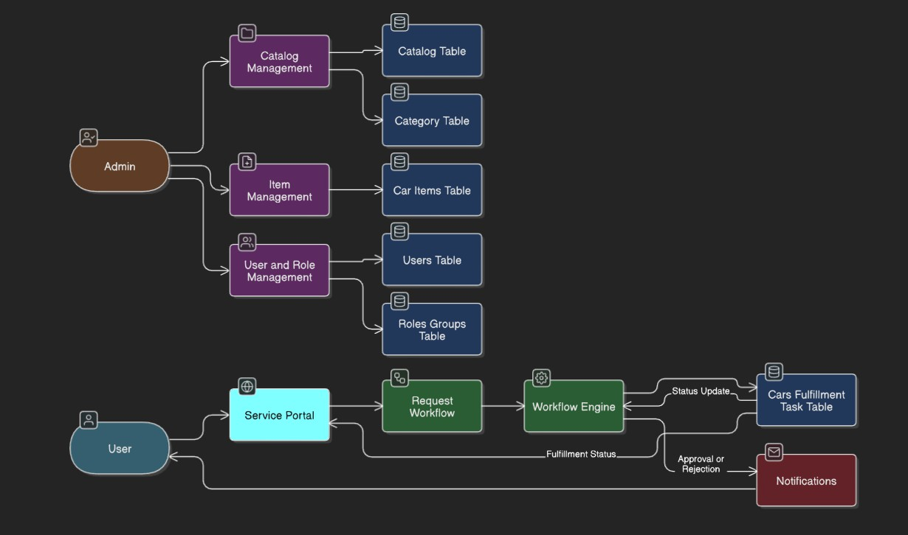

User Stories

User Type | Functional  Requirement (Epic) | User Story Number | User Story / Task | Acceptance criteria | Priority | Release
Administrator | Catalog Creation | USN-1 | As an admin, I can create a catalog named "Mahendra" with a description and global scope. | Mahendra catalog is visible in the system with correct attributes. | High | Sprint-1
Administrator | Category Setup | USN-2 | As an admin, I can create categories: Sudden, XUV, and Sports. | All three categories are listed under Mahendra catalog. | High | Sprint-1
Administrator | Car Item Entry | USN-3 | As an admin, I can add Polo, Thar, and XUV700 cars with short and long descriptions, images, pricing, and  category. | Each item appears in correct category and is fully populated. | High | Sprint-1/2
Administrator | User Management | USN-4 | As an admin, I can create a user with ID "01" and assign the role "emp1". | User exists in the system with correct role. | Medium | Sprint-2
Administrator | Role/Group Management | USN-5 | As an admin, I can create role "emp1" and group "showroom" managed by Abraham Lincoln with members. | Group is available with proper members and assigned manager. | Medium | Sprint-2
Administrator | Table Setup | USN-6 | As an admin, I can create a table "cars fulfillment" extending the Task table. | Table is visible in  schema with linkage to task management. | High | Sprint-3
Administrator | Workflow Setup | USN-7 | As an admin, I can create workflow for catalog requests including 2-step approval  and task creation. | Workflow shows correct transitions, approvals,  and task actions. | High | Sprint-3
Administrator | Notifications | USN-8 | As an admin, I can configure  approval/rejection notifications with dynamic content and HTML format. | Emails are triggered  with relevant details and formatting. | Medium | Sprint-3

User Type | Functional Requirement  (Epic) | User Story Number | User Story / Task | Acceptance criteria | Priority | Release
Web User | Order Item via Portal | USN-9 | As a user, I can browse and order car items via the Service Portal and view approval status. | User sees confirmation with request number, approval status, and email notification. | High | Sprint-4
Admin/User | Task Update & Completion | USN-10 | As an approver, I can approve/reject requests, and task state is updated accordingly. | Tasks reflect proper status (Ready to Pickup/Deployment Failed). | High | Sprint-4

